**UNIVERSITY OF OKLAHOMA**

**DEPARTMENT OF DATA SCIENCE AND ANALYTICS**

**Practicum Report**

**on**

**CUSTOMER BEHAVIOUR SIMULATION**

**Advisor: Dr. Charles Nicholson**

**By**

**Gowtham Talluru**

**Summer-2017 (1 credit)**

# **1. Introduction:**

The objective of this study is to simulate the behavior of tenants (Customers) and landlords (Vendors) during marketing period of new lease term. The market of landlords and tenants in a area has a different kind of dynamics especially in University towns. The landlords of which most of them are massive apartment complexes advertise with different offers for a few months before the start of academic year to obtain as many leases as possible. They also follow dynamic pricing based on the fill up rate. Whereas students depending of their awareness and preferences sign contract with the landlords during anytime in the marketing season. The decision-making behavior of customers is simulated in this study to understand better marketing strategies for landlords on macro scale.

Population of customers having a range of preferences, sensitivity to various advertising channels and time after which they start actively looking for new lease was generated. Similarly, population of landlords with a range of amenities, rent as a function of amenities, schedule of updating rent based on occupancy was generated. The interactions between customers and vendors was simulated over a time period which is divided into different phases. During these phases, vendors advertise themselves through various channels and the awareness of the customers for respective vendor increases depending on the sensitivity of the customers to the respective advertisement channel. At each marketing phase, customers evaluate the vendors based on compatibility, advertisement effort, compatibility score of the vendor among friends, expected rent and rent offered by the vendor. After evaluating the vendors based on the combination of these factors, tenants will sign contract with the landlord having best score and will get out the prospective customer pool for that season. Similarly, at each marketing phase landlords will update the rent based on the new contracts they have obtained.

This simulation will be run on various demand and supply scenarios to understand the market behavior and to identify marketing strategies that should be followed by landlords to maximize their revenues. The complexity of the study can be further increased by adding various decision-making strategies and constraints on the behavior of tenants and landlords.

# **2. Methodology:**

The methodology of the study is divided into three sections

1. Generating a population of customers (Tenants) having different combination of personal attributes such as preference to various facilities, sensitivity to various advertisement channels, weightage to feedback gathered from friends and time when they start looking for a new lease.
2. Generating a set of vendors (Apartment complexes) having different combination of amenities, pricing as a function of amenities, different preference to advertising channels, strategy to update rent during the marketing season and different fill up targets.
3. Simulate the system behavior during marketing period in various scenarios and evaluate the strategies followed by vendors to gain maximum profit.

## **2.1 Customer population**

The customer population is characterized by parameters representing preferences, sensitivity to various advertisement channels, sensitivity to suggestions from friends, preferred time for signing new contract, expectations on price discount etc. All these preferences are expressed on a scale of 0 to 10 and generated using random number generated. In a few instances, the preferences may cross the limit due to the type of distribution techniques but it will not affect the study. **Table 1** shows the distribution and significance of various parameters used to characterize the customer population. The preferred rent of customers is expressed as a function of preference to various facilities as shown below.

$Prefered Rent=\left(P_{f1}+ P_{f2}+ P_{f3}+ P_{f4}+ P_{f5}+P_{f6}+P_{f7}\right)*tenant expectation$ [1]

|  |  |  |  |
| --- | --- | --- | --- |
| **Parameter** | **Mean** | **Standard deviation** | **Significance** |
| Income (Dollars) | 1000 | 200 | Income of tenants (Students) |
| $$P_{f1}, P_{f2}, P_{f3},P_{f4},$$ $$P_{f5}, P_{f6}, P_{f7}$$ | 6 | 2 | Preferences of the customers to various facilities f1, f2, f3, f4, f5, f6 and f7.  Example: Cleanliness, Distance to school, Furnished, Vintage etc. |
| Email sensitivity,  Event sensitivity,  Social sensitivity | 4 | 3 | Sensitivity of the tenants to various advertising channels like email, campus events and word of mouth from friends. |
| Time factor | 5 | 4 | Tendency of tenants to wait before signing a contract. |
| Preferred Rent | - | - | Preferred rent as a function of preferences to facilities. |
| Status | Binary | | Tenants lease status for coming year. |

**Table 1: Parameters characterizing customer population**

## **2.2 Vendor Population**

The population of Vendors is characterized by parameters representing facilities provided, available capacity, costs associated with various marketing campaigns, minimum and maximum rent that can be offered, price update strategies etc. **Table 2** shows the distribution and significance of various parameters related to vendors. The expected rent of landlords based on the facilities offered is as shown below.

$Expected Rent=\left(V_{f1}+ V_{f2}+ V_{f3}+ V_{f4}+ V_{f5}+V_{f6}+V_{f7}\right)*vendor expectation$ [2]

As observed in a practical scenario, vendor expectation will be initially higher than customer expectation. The price offered by the vendors will be updated in each marketing phase based on the occupancy obtained and target occupancy till that phase as shown in **Eq-3** and **Eq-4**. If the $Occupancy_{phase}$ is more than the $Target Occupancy_{Phase}$ vendors will increase the price for next phase and vice versa. Target fraction explains how the target occupancy is divided over the marketing period. Target fraction of one indicates that the total number of leases available with the vendor are evenly distributed among the marketing phases. Target fraction of two indicates that the vendor wants to fill all the available leases by the mid of marketing season. The pricing strategy of vendors can be varied by varying starting price fraction and target fraction.

$Target Occupancy_{phase}=\frac{Capacity}{No of marketing phases}*current phase*Target fraction$ [3]

$Current Rent_{phase}=Expected Rent*\left(\frac{Occupancy_{phase}}{Expected Occupancy_{phase}}\right)$ [4]

|  |  |  |  |
| --- | --- | --- | --- |
| **Parameter** | **Mean** | **Standard deviation** | **Significance** |
| $$V_{f1}, V_{f2},V_{f3},V_{f4},$$ $$V_{f5}, V_{f6}, V_{f7}$$ | 8 | 1 | Facilities f1, f2, f3, f4 and f5 offered by the landlord on scale of 10 |
| Starting price fraction | - | - | Rent at the start of marketing season as a fraction of expected rent |
| Expected rent | - | - | Expected rent by landlord as a function of facilities offered. |
| Target Fraction | - | - | Parameter representing the occupancy targets of vendor phase by phase. |

**Table 2: Parameters characterizing vendor population**

## **2.3 Compatibility between Customers and Vendors**

In a market with $n$ tenants (Customers) and $m$ landlords (Vendors), compatibility matrix will be of dimension $n X m$ in which element (n, m) represent the compatibility between customer n and vendor m. The customer matrix will be of the dimension $n X f$ where f is the number of independent facilities based on which compatibility score is calculated. Similarly, vendor matrix will be of the dimension $f X m$. If a customer has high preference for a facility $f_{1}$ and a vendor has a high rating for that facility, then the contribution of that facility to the respective compatibility score will be high. The evaluation of compatibility matrix is shown below

$C_{nXm}=T_{nXf} X L_{fXm}$ [5]

The awareness of the customers about various vendors depends on the promotion activities conducted by various vendors thorough different channels. Whenever a vendor contacts a customer, the awareness score of the customer to that vendor increases. The increase in the score will be proportion to the sensitivity of the customer to the communication channel. The awareness score of each customer for a vendor can be expressed as shown below

$A_{campaign_{n,m}}= \sum_{i=1}^{k}{S_{n,k}* I_{n,k,m}}$ s [6]

In the above equation $A_{campaign_{n,m}}$ represents the awareness of customer $n$ towards vendor $m.$ $S_{n,k}$ represents the sensitivity of customer $n$ to marketing channel $k$. $I_{n,k,m}$ is an indicator variable representing whether customer $n$ is contacted by vendor $m$ through marketing channel $k$.

In addition to this, the awareness of customers to various vendors is further affected by awareness among friends. This kind of awareness of customers for various vendors is modelled as shown below.

$A_{social_{n,m}}=\frac{\left(\sum_{i=1}^{l}{A_{n-i, m}}\right)}{f}$ [7]

$l$ is the number of friends each customer has and it can be varied during the study. This number is initialized to 2 in this study. Both campaign and social awareness scores will be reduced by a certain rate after each phase throughout the marketing season until they reach a minimum. Once the awareness of a customer crosses this limit, it cannot go below that with time.

The rent ratio of each customer to all prospective vendors is the ratio of expected rent of the customer to the rent offered by each vendor. The compatibility score of each customer is multiplied by rent ratio to obtain final score to make a decision. The rent ratio of each customer to each vendor is defined as follows.

$Rent Ratio_{n,m}=\frac{Prefered Rent_{n}}{Expected Rent_{m}}$ [8]

The final decision made by the customers to sign a lease with any vendor will be a function of awareness, compatibility and rent ratio. Each customer will have a total score for each vendor based on awareness, compatibility and rent ratio as shown below

$Total score_{n,m}=\left({αC}_{n,m}+{βA}_{campaign_{n,m}}+γA_{social_{n,m}}\right)* {(Rent Ratio_{n,m})}^{δ}$ [9]

The parameters $α$, $β$, $γ$ and $δ$ will signify the effect of each factor on the decision of the customer. These factors can be modelled as a function of personal traits of the customers. In this study these factors are initialized to one and kept uniform throughout the customer population.

## **2.4 Customer Decision**

Customer decision in this simulation study represents tenants signing contract with landlord for next year. Once customer signs contract with a landlord, he will be out of the prospective customer pool and he will also stop looking for a new lease. Customer decision to sign a new lease is modelled as follows

1. Customers will keep looking for an ideal rent among the vendors during the marketing season and he will sign the lease if he finds an ideal rent ratio with certain threshold of compatibility, awareness and rent ratio.
2. If ideal rent is not found until a certain time period, he will sign the lease with the vendor having maximum score as shown in **Eq- 9**.
3. In both the above cases, the amount of rent should not exceed certain fraction of customer’s total income which is set to default value of 0.75. Depending on the balance between supply and demand, customers may get better price based on the time they sign the lease.

## **2.5 Tuning Parameters**

A few parameters used to model the system were kept dynamic to run various scenarios. Table 3 shows various tuning parameters, their default values in base case and their significance in the study. The parameters Number of customers, Number of vendors and Capacity per vendor can be varied to run various demand and supply scenarios. Parameters customer expectation and vendor expectation can be varied to change the contrast between rent customers are willing to pay and rent vendors are offering. Increasing the difference between these parameters will increase the contrast between customer expected rent and vendors offered rent and vice versa. The other parameters are defined to make the model as close as possible to the real-world scenario.

|  |  |  |
| --- | --- | --- |
| **Parameter** | **Default Value** | **Significance** |
| No of customers | 1500 | Total number of customers in the study |
| No of Vendors | 3 | Total number of vendors in the study |
| Capacity Per Vendor | 500 | Number of leases available with each vendor |
| No of marketing phases | 20 | Steps in which apartments update prices |
| Customer expectation | 8 | Factor relating customers expected facilities and price he is willing to pay |
| Vendor expectation | 11 | Factor relating vendors available facilities and price he is expecting |
| Email points factor | 5 | Factor relating increment in awareness points and sensitivity of the customer to email |
| Event points factor | 5 | Factor relating increment in awareness points and sensitivity of the customer to campus events. |
| Campaign points reduced per phase | 20 | Reduction in the awareness points with each marketing phase |
| Residual campaign points | 100 | Minimum awareness points after which there will be no further reduction with time |

**Table 3: Tuning parameters used in the** **study**

# **3. Model behavior in various demand and supply scenarios**

## **3.1 Equal supply and demand scenario**

The base case scenario is run by keeping both demand and supply equal. All other tuning parameters were kept same as shown in previous section. **Figure 1** shows the dynamic changes in price of vendor-1 with respect to occupancy rate during marketing period. It can be observed from Figure 1 that the model has captured the dynamics of the market satisfactorily.

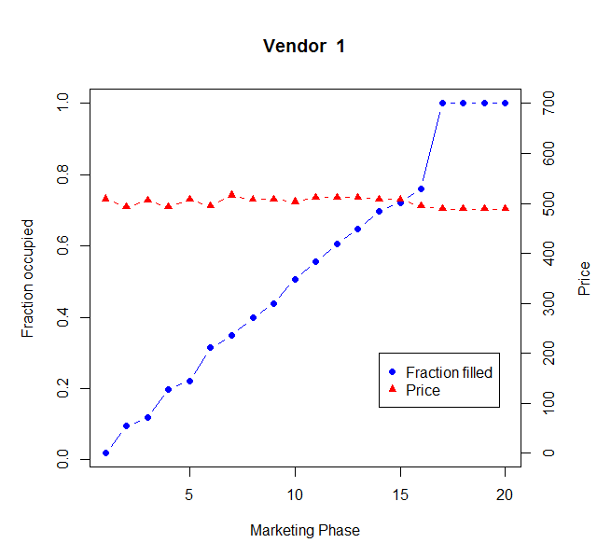

**Figure 1: Price changes and occupancy of vendor-1 during marketing season (Base case)**

It can also be observed that the general tendency of the vendors to increase the price if there is good fill up and to decrease the price during poor fill up is also reflected in **Figure 1**. **Table 4** shows revenue generated by all the vendors and other relevant metrics. **Table 5** shows the price changes made by vendors depending on their rate of fill up during the marketing season.

|  |  |  |  |
| --- | --- | --- | --- |
|  | **Vendor-1** | **Vendor-2** | **Vendor-3** |
| Total Revenue | 249,896 | 262,404 | 246,119 |
| Number of leases filled | 500 | 500 | 461 |
| % of leases filled | 100% | 100% | 92% |
| Starting price | $509 | $512 | $577 |
| Price at the end | $488 | $530 | $532 |

Table 4: Revenue metrics of Vendors (Base case)

|  |  |  |  |  |  |  |
| --- | --- | --- | --- | --- | --- | --- |
| **Phase No.** | **Price ($)** | | | **Fill up** | | |
| **Vendor-1** | **Vendor-2** | **Vendor-3** | **Vendor-1** | **Vendor-2** | **Vendor-3** |
| 1 | 509 | 513 | 578 | 9 | 191 | 0 |
| 3 | 506 | 658 | 528 | 59 | 191 | 42 |
| 5 | 508 | 606 | 522 | 111 | 191 | 95 |
| 7 | 516 | 557 | 536 | 174 | 203 | 149 |
| 9 | 508 | 527 | 537 | 219 | 250 | 188 |
| 11 | 512 | 530 | 543 | 278 | 310 | 244 |
| 13 | 512 | 535 | 542 | 324 | 348 | 290 |
| 15 | 508 | 524 | 540 | 361 | 385 | 345 |
| 17 | 489 | 530 | 525 | 500 | 500 | 461 |
| 19 | 489 | 530 | 590 | 500 | 500 | 461 |
| 20 | 489 | 530 | 562 | 500 | 500 | 461 |

**Table 5: Price changes and occupancy during marketing season (Base case)**

## **3.2 Demand more than Supply**

In this scenario, the number of customers (2200) looking for a lease is higher than the number of leases (1500) available. In this case, it is obvious that all the vendors will get easily filled up. The objective of the vendors in this scenario is to maximize the revenue. **Figure 2** shows the dynamic changes in price of vendor-1 with respect to occupancy rate in the scenario of demand more than supply. The starting price and price update factor is kept same as base case scenario initially. It can be observed that the price has gone much higher than the base price and final dynamic price observed in the previous case. The dynamic pricing in this study is controlled by two parameters. One is starting rate as a multiple of base rate and the other is factor connecting fill-up target and price update. The study will be carried out by keeping vendor-1 parameters variable and vendor-2 and vendor-3 parameters same as base case. The resulting 3D-plot of starting rate, price update factor and revenue will provide best combination of these parameters for obtaining maximum revenue.

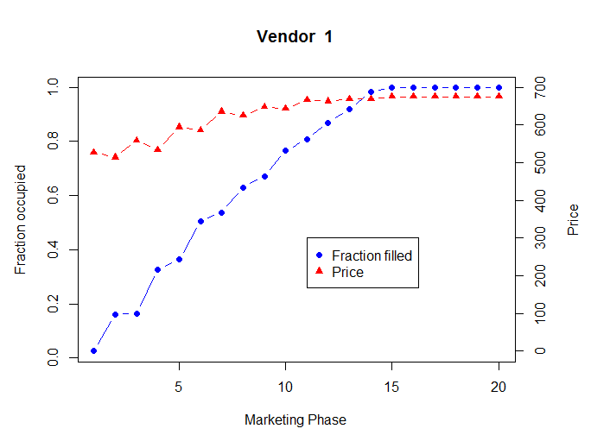

Base Price

**Figure 2: Price changes and occupancy of vendor-1 in case of demand more than supply**

|  |  |  |  |
| --- | --- | --- | --- |
|  | **Vendor-1** | **Vendor-2** | **Vendor-3** |
| Total Revenue | 299,366 | 289,392 | 257,333 |
| Number of leases filled | 500 | 500 | 500 |
| % of leases filled | 100% | 100% | 100% |
| Starting price | $526 | $515 | $471 |
| Price at the end | $675 | $688 | $581 |

**Table 6: Revenue metrics of Vendors (Demand more than supply)**

**Figure 3** and **Figure 4** shows the pricing strategy of vendor-1 with varying one of the parameters among starting price fraction and target fraction. In **Figure 3** three cases representing starting price fraction of 0.7, 1, 1.3 with target fraction of 1 resulted in revenue of $ 212K, $284K, $278K respectively. It can be observed that the vendor achieved 75% occupancy at very first phase with 0.7 starting price factor but the total revenue of this case is less than the other two cases. Three cases representing target fraction of 0.7, 1, 1.3 with starting price factor of 1 in **Figure 4** resulted in a total revenue of $299K, $284K, $273K respectively. **Figure 5** shows the sensitivity analysis between starting price factor, target fraction and revenue. A clear trend can be observed indicating that more revenue can be achieved by keeping the target fraction low in case of demand more than supply. The maximum revenue of $299K was realized with starting price factor of 1 and target fraction of 0.7.

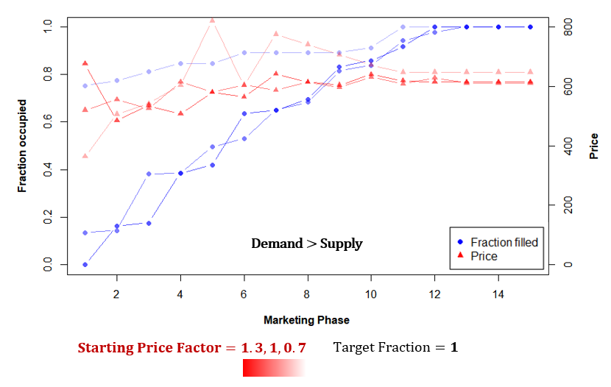

**Figure 3: Pricing strategy of vendor-1 with varying starting price factor (Demand > Supply)**

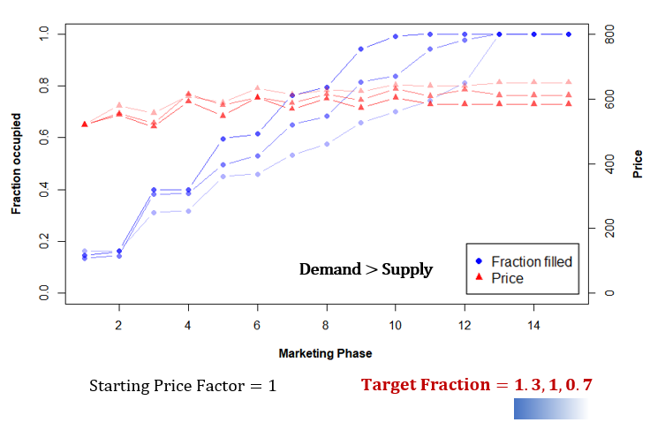

**Figure 4: Pricing strategy of vendor-1 with varying target fraction (Demand > Supply)**

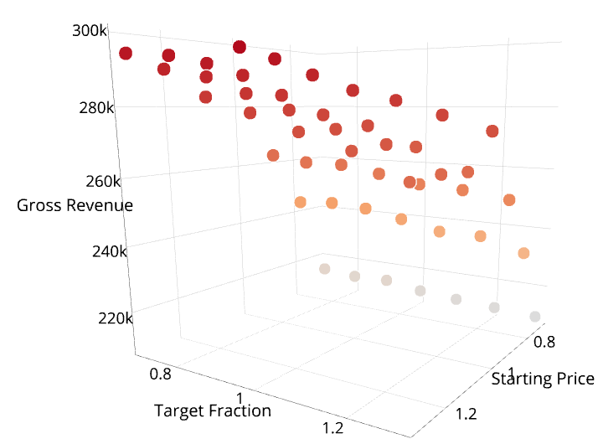

**Figure 5: Sensitivity analysis (Demand > Supply)**

## **3.3 Demand less than Supply**

In this scenario, the number of customers (750) looking for a lease is half the number of leases (1500) available. The starting price and price update factor of vendors play a crucial role in this scenario to maximize their revenues. Offering right price at right time plays an important role in attaining maximum leases and revenue for the vendors. **Figure 6** shows the dynamic changes in price of vendor-1 w.r.t to occupancy rate in this scenario. The starting price and price update factor is kept same as base case scenario. It can be observed that the price has gone much lower than the base price due to higher supply than demand.

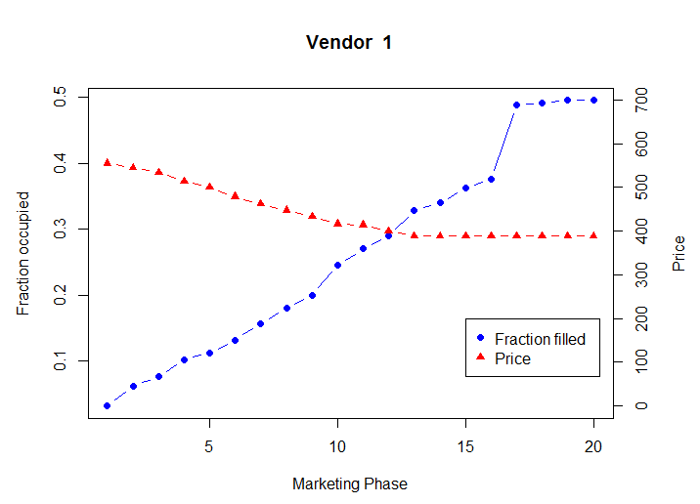

Base Price

**Figure 6: Price changes and occupancy of vendor-1 in case of supply more than demand**

|  |  |  |  |
| --- | --- | --- | --- |
|  | **Vendor-1** | **Vendor-2** | **Vendor-3** |
| Total Revenue | 108,555 | 113,884 | 130,841 |
| Number of leases filled | 248 | 260 | 308 |
| % of leases filled | 50% | 52% | 62% |
| Starting price | $509 | $512 | $577 |
| Price at the end | $488 | $530 | $532 |

**Table 7: Revenue metrics of Vendors (Demand less than supply)**

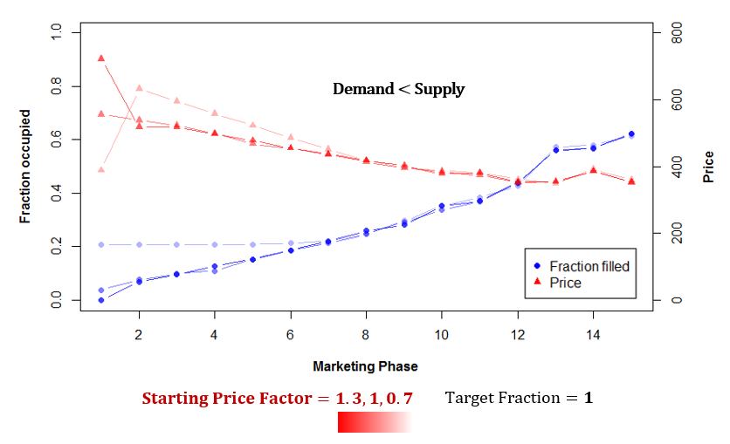

**Figure 7:Pricing strategy of vendor-1 with varying starting price factor (Demand < Supply)**

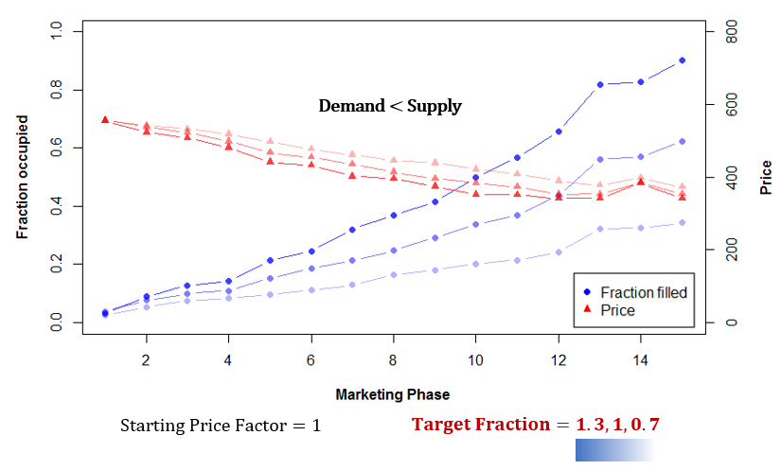

**Figure 8: Pricing strategy of vendor-1 with varying target fraction (Demand < Supply)**

**Figure 7** and **Figure 8** shows the pricing strategy of vendor-1 with varying one of the parameters among starting price fraction and target fraction. It is interesting to observe that the 3 cases representing different starting price fraction converged after a few marketing phases. This is because of the market dynamics and indicates the effectiveness of the model in capturing the market behavior. In **Figure 7** three cases representing starting price fraction of 0.7, 1, 1.3 with target fraction of 1 resulted in revenue of $ 116K, $128K, $127K respectively. In case of demand less than supply, the occupancy is more sensitive to target fraction than starting price factor. Three cases representing target fraction of 0.7, 1, 1.3 with starting price factor of 1 in **Figure 8** resulted in a total revenue of $76K, $128K, $176K respectively. It can also be observed that significant difference in occupancy and revenue has been realized with varying target ratio in case of demand less than supply. **Figure 9** shows the relationship between starting price factor, target fraction and revenue. It can be observed that when demand is less than supply, higher target fractions resulted in higher revenues. It can also be observed that, starting price factor does not have significant effect on the revenue.

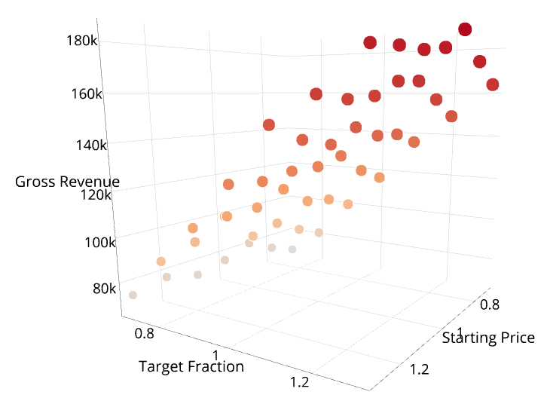

**Figure 9: Sensitivity Analysis (Demand < Supply)**

# **4. Conclusions**

The conclusions for the above study are as follows.

1. The behavior of landlord- tenant market in an area can be simulated using Agent based modelling. This model can be used to understand the behavior of the market in various demand and supply scenarios. It can also be used to determine better pricing strategies for vendors.
2. When demand is less than supply, (Starting price factor 0.9 and Target fraction 1.3) resulted in maximum revenue. In general, when demand is less than supply, keeping fill up targets high and updating the price accordingly will result in better revenues for the vendors.
3. When demand is more than supply (Starting rent factor 1 and Target fraction 0.7) resulted in maximum revenue. In general, when demand is more than supply, keeping the fill up targets low and starting with a moderate rent will result in better revenues for the vendors.
4. Among the two parameters governing pricing strategy in this study, target fraction had more significance in effecting the revenue of vendors. This could be due to its continuous influence on the rent at each phase. Whereas starting rent fraction will have influence initially but will get masked by the effect of target fraction in the later phases.

# Appendix-A (R-code)

# Tuning Parameters set-1

noOfCustomers = 2000

noOfVendors = 3

capacityPerVendor=500

customer_expectation= 8

vendor_expectation = 11

minimumPriceFactor = 0.4

maximumPriceFactor = 2

set.seed(1)

# ------------------------------Customer Data frame ----------------------------

customer_Df_static <- data.frame(id = 1:noOfCustomers,

income = rnorm(noOfCustomers,1000,200),

sex=rbinom(noOfCustomers, 1, 0.5),

p_clean=rnorm(noOfCustomers,6,2),

p_distance=rnorm(noOfCustomers,5,2),

p_f1=rnorm(noOfCustomers,6,2),

p_f2=rnorm(noOfCustomers,6,2),

p_f3=rnorm(noOfCustomers,6,2),

p_f4=rnorm(noOfCustomers,6,2),

p_f5=rnorm(noOfCustomers,6,2),

email_sensitivity = rnorm(noOfCustomers, 6, 2),

campus_event_sensitivity = rnorm(noOfCustomers, 6, 2),

social_sensitivity = rnorm(noOfCustomers, 6, 2),

social_factor= rnorm(noOfCustomers,6,2),

time_factor = rnorm(noOfCustomers,5,4),

expected_discount = rnorm(noOfCustomers, 50, 10),

status = 0,

signed_in_marktng_phase=0,

contract_price=0)

customer_Df_static$price_factor_1 = (customer_Df_static$p_clean + customer_Df_static$p_f1 +

customer_Df_static$p_f2 + customer_Df_static$p_f3 + customer_Df_static$p_f4 +

customer_Df_static$p_f5) * customer_expectation

# ------------------------------- Vendor Data frame -------------------------------

vendor_Df_static <- data.frame(id = 1:noOfVendors,

v_clean=rnorm(noOfVendors,8,1),

v_distance=rnorm(noOfVendors,8,2),

v_f1=rnorm(noOfVendors,8,1),

v_f2=rnorm(noOfVendors,8,1),

v_f3=rnorm(noOfVendors,8,1),

v_f4=rnorm(noOfVendors,8,1),

v_f5=rnorm(noOfVendors,8,1),

capacity = capacityPerVendor,

emailcost=0,

social_event_cost = 0,

target_fraction_per_phase= c(1,1,1),

starting_price_fraction = c(1,1,1),

filled = 0,

total_revenue=0)

vendor_Df_static$price_factor_1 = (vendor_Df_static$v_clean + vendor_Df_static$v_f1 +

vendor_Df_static$v_f2 + vendor_Df_static$v_f3 + vendor_Df_static$v_f4 +

vendor_Df_static$v_f5) *vendor_expectation

vendor_Df_static$minimum_price = vendor_Df_static$price_factor_1*minimumPriceFactor

vendor_Df_static$maximum_price = vendor_Df_static$price_factor_1*maximumPriceFactor

vendor_Df_static$Current_price = vendor_Df_static$price_factor_1* vendor_Df_static$starting_price_fraction

vendor_Df_static$Current_price_calculated = vendor_Df_static$Current_price

#--------------------------------Tuning Parameters set-2------------------------------------------

best_rent_Ratio = 1

email_points_factor=5

event_points_factor=5

campaign_points_reduced_per_phase = 20

residual_campaign_points = 100

minimum_awareness_points=70

maxFractionOfImcomeForRent = 0.75

noOfCustPerDay=300

noOfMarketingPhases=15

#Sensitivity analysis parameters

startingPriceRange<-seq(from=1, to=1, by=1)

priceUpdateFactor<- seq(from=1, to=1, by=1)

#--------------------------------- Sensitivity Analysis Record -------------------------------------

Sensitivity <- data.frame(startingPrice = rep(0, length(startingPriceRange)*length(priceUpdateFactor)),

priceUpdate= rep(0, length(startingPriceRange)*length(priceUpdateFactor)),

revenue = 0)

# Dataframe with all possible combinations of startingPrice and PriceUpdate

kkk=1

for(iii in 1:length(startingPriceRange)){

for(jjj in 1:length(priceUpdateFactor)){

Sensitivity[kkk,1] = startingPriceRange[iii]

Sensitivity[kkk,2] = priceUpdateFactor[jjj]

kkk=kkk+1

}

}

for(case in 1:nrow(Sensitivity)){

vendor_Df<-vendor_Df_static

customer_Df<-customer_Df_static

vendor_Df$starting_price_fraction[1] = Sensitivity[case,1]

vendor_Df$Current_price[1]= vendor_Df$price_factor_1[1] * Sensitivity[case,1]

vendor_Df$Current_price_calculated = vendor_Df$Current_price

vendor_Df$target_fraction_per_phase[1] = Sensitivity[case,2]

#------------------------------- Customer Vendor relations ----------------------

# Data frame for recording parameters connecting customers and vendors.

##

customer_vendor_connection <- data.frame(id = 1:noOfCustomers,

v1_email = 0,v2_email = 0,v3_email = 0,

v1_event = 0,v2_event = 0,v3_event = 0,

v1_compatibility_score = 0,v2_compatibility_score = 0,v3_compatibility_score = 0,

v1_social=0, v2_social=0, v3_social=0,

timing_ratio=0,

v1_rentRatio=0, v2_rentRatio=0, v3_rentRatio=0)

#-----------------------------Changes with time-------------------------------------

# Data frame for recording vendor prices with time

phase_wise_vendor_status <- data.frame(phase_No = 1:noOfMarketingPhases,

vendor1_price=0,

vendor2_price=0,

vendor3_price=0,

vendor1_filled=0,

vendor2_filled=0,

vendor3_filled=0,

vendor1_revenue=0,

vendor2_revenue=0,

vendor3_revenue=0)

#--------------------- Marketing phases-----------------------------------------------

for(t in 1:noOfMarketingPhases){

##------------------- Advertizement effect----------------------------------------------------------------------------------

v1_email<-sample(1:noOfCustomers, noOfCustPerDay/2, replace = F)

v2_email<-sample(1:noOfCustomers, noOfCustPerDay/2, replace = F)

v3_email<-sample(1:noOfCustomers, noOfCustPerDay/2, replace = F)

v1_event<-sample(1:noOfCustomers, noOfCustPerDay/2, replace = F)

v2_event<-sample(1:noOfCustomers, noOfCustPerDay/2, replace = F)

v3_event<-sample(1:noOfCustomers, noOfCustPerDay/2, replace = F)

##

customer_vendor_connection$v1_email[v1_email]= customer_vendor_connection$v1_email[v1_email] + customer_Df$email_sensitivity[v1_email] * email_points_factor

customer_vendor_connection$v2_email[v2_email]=customer_vendor_connection$v2_email[v2_email] + customer_Df$email_sensitivity[v2_email] * email_points_factor

customer_vendor_connection$v3_email[v3_email]=customer_vendor_connection$v3_email[v3_email] + customer_Df$email_sensitivity[v3_email] * email_points_factor

customer_vendor_connection$v1_event[v1_event]=customer_vendor_connection$v1_event[v1_event]+ customer_Df$campus_event_sensitivity[v1_event] * event_points_factor

customer_vendor_connection$v2_event[v2_event]=customer_vendor_connection$v2_event[v2_event]+ customer_Df$campus_event_sensitivity[v2_event] * event_points_factor

customer_vendor_connection$v3_event[v3_event]=customer_vendor_connection$v3_event[v3_event]+ customer_Df$campus_event_sensitivity[v3_event] * event_points_factor

#----------------------- Evaluation of each vendor by customers ------------------------------------

customer_vendor_connection$v1_rentRatio <- customer_Df$price_factor_1/vendor_Df$Current_price[1]

customer_vendor_connection$v2_rentRatio <- customer_Df$price_factor_1/vendor_Df$Current_price[2]

customer_vendor_connection$v3_rentRatio <- customer_Df$price_factor_1/vendor_Df$Current_price[3]

#customer_vendor_connection$timing_ratio <- customer_Df$time_factor/t

for ( i in 1: noOfCustomers){

for (j in 1:noOfVendors){

#Compatability score

customer_vendor_connection[i, j+7] <- sum(as.vector(vendor_Df[j,2:8]) * as.vector(customer_Df[i,4:10]))

#Social score

if(i>2){

customer_vendor_connection[i, j+10] <- ((customer_vendor_connection[i-1,j+7]) +

customer_vendor_connection[i-2,j+7])*customer_Df$social_sensitivity[i]/10

}else{

customer_vendor_connection[i,j+10] = ((customer_vendor_connection[i+1,j+7]) +

customer_vendor_connection[i+2,j+7])*customer_Df$social_sensitivity[i]/10

}

}

}

customer_vendor_connection$v1_totalScore <- (customer_vendor_connection$v1_compatibility_score + customer_vendor_connection$v1_social +

customer_vendor_connection$v1_email +

customer_vendor_connection$v1_event)*customer_vendor_connection$v1_rentRatio

customer_vendor_connection$v2_totalScore <- (customer_vendor_connection$v2_compatibility_score + customer_vendor_connection$v2_social +

customer_vendor_connection$v2_email +

customer_vendor_connection$v2_event)*customer_vendor_connection$v2_rentRatio

customer_vendor_connection$v3_totalScore <- (customer_vendor_connection$v3_compatibility_score + customer_vendor_connection$v3_social +

customer_vendor_connection$v3_email +

customer_vendor_connection$v3_event)*customer_vendor_connection$v3_rentRatio

# ---------------------Comparision and purchase of contract by each customers-------------------

marketingPhase_on_scale_10 <- t*10/noOfMarketingPhases

for (i in 1: noOfCustomers){

if((customer_Df$status[i]==0)&& (max(customer_vendor_connection[i,15:17])>1)){

temp=which.max(customer_vendor_connection[i, c("v1_totalScore", "v2_totalScore","v3_totalScore")])

if(customer_vendor_connection[i,temp+7]> quantile(customer_vendor_connection[,temp+7], 0.75) && #Compatibility

((customer_vendor_connection[i,temp+1] + customer_vendor_connection[i,temp+4]) > minimum_awareness_points ) && #Awareness

(vendor_Df$Current_price[temp]< customer_Df$income[i]*maxFractionOfImcomeForRent)){ # Price

customer_Df$status[i]=temp

vendor_Df$filled[temp]=vendor_Df$filled[temp]+1

vendor_Df$total_revenue[temp]= vendor_Df$total_revenue[temp] + vendor_Df$Current_price[temp]

customer_Df$contract_price[i] = vendor_Df$Current_price[temp]

customer_Df$signed_in_marktng_phase[i] = t

phase_wise_vendor_status[t, 7+temp]= phase_wise_vendor_status[t, 7+temp] +

vendor_Df$Current_price[temp]

}

}

if((customer_Df$status[i]==0) && ((customer_Df$time_factor[i]<marketingPhase_on_scale_10) ||

(marketingPhase_on_scale_10>8))||(max(customer_vendor_connection[i,15:17])>1)){

temp=which.max(customer_vendor_connection[i, c("v1_totalScore", "v2_totalScore","v3_totalScore")])

if((vendor_Df$filled[temp]<vendor_Df$capacity[temp])&&

((vendor_Df$Current_price[temp]< customer_Df$income[i]*maxFractionOfImcomeForRent))){

customer_Df$status[i]=temp

vendor_Df$filled[temp]=vendor_Df$filled[temp]+1

vendor_Df$total_revenue[temp]= vendor_Df$total_revenue[temp] + vendor_Df$Current_price[temp]

customer_Df$contract_price[i] = vendor_Df$Current_price[temp]

customer_Df$signed_in_marktng_phase[i] = t

phase_wise_vendor_status[t, 7+temp]= phase_wise_vendor_status[t, 7+temp] +

vendor_Df$Current_price[temp]

}

}

}

# ------------------- Phase wise status of vendors ----------------------------------------------------------

phase_wise_vendor_status$vendor1_price[t]=vendor_Df$Current_price[1]

phase_wise_vendor_status$vendor2_price[t]=vendor_Df$Current_price[2]

phase_wise_vendor_status$vendor3_price[t]=vendor_Df$Current_price[3]

phase_wise_vendor_status$vendor1_filled[t]=vendor_Df$filled[1]

phase_wise_vendor_status$vendor2_filled[t]=vendor_Df$filled[2]

phase_wise_vendor_status$vendor3_filled[t]=vendor_Df$filled[3]

if(t>1){

phase_wise_vendor_status$vendor1_revenue[t]=phase_wise_vendor_status$vendor1_revenue[t]+

phase_wise_vendor_status$vendor1_revenue[t-1]

phase_wise_vendor_status$vendor2_revenue[t]=phase_wise_vendor_status$vendor2_revenue[t]+

phase_wise_vendor_status$vendor2_revenue[t-1]

phase_wise_vendor_status$vendor3_revenue[t]=phase_wise_vendor_status$vendor3_revenue[t]+

phase_wise_vendor_status$vendor3_revenue[t-1]

}

# -------------------Price update by Vendors-----------------------------------------------------------------

vendor_Df$expected_fillup = (vendor_Df$capacity * vendor_Df$target_fraction_per_phase * t / noOfMarketingPhases)

vendor_Df$Current_price_calculated = ifelse(vendor_Df$filled<vendor_Df$capacity, (vendor_Df$price_factor_1*

(((vendor_Df$filled - vendor_Df$expected_fillup)/vendor_Df$capacity)+1)),

vendor_Df$Current_price_calculated)

vendor_Df$Current_price = ifelse(vendor_Df$Current_price_calculated>vendor_Df$minimum_price, vendor_Df$Current_price_calculated,

vendor_Df$minimum_price)

vendor_Df$Current_price = ifelse(vendor_Df$Current_price>vendor_Df$maximum_price, vendor_Df$maximum_price,

vendor_Df$Current_price)

# Vendor-1 price should not exceed other vendors by 30%

mn = min(vendor_Df$Current_price[2], vendor_Df$Current_price[3])

mx = max(vendor_Df$Current_price[2], vendor_Df$Current_price[3])

if(vendor_Df$Current_price[1]>= 1.3*mx)

vendor_Df$Current_price = mx

if(vendor_Df$Current_price[1]<= 0.7*mn)

vendor_Df$Current_price[1] = mn

# ------------------- Reduction in awareness among customers per phase --------------------------------------

for(i in 1:noOfCustomers){

for(j in 1:noOfVendors*2){

if(customer_vendor_connection[i,j+1] > residual_campaign_points + campaign_points_reduced_per_phase){

customer_vendor_connection[i,j+1] = customer_vendor_connection[i, j+1] - campaign_points_reduced_per_phase

}

}

}

}

Sensitivity$revenue[case]=vendor_Df$total_revenue[1]

print(phase_wise_vendor_status)

print(vendor_Df)

print(Sensitivity[case,])

case_id=paste("cusNo_", noOfCustomers,"_sp_", Sensitivity$startingPrice[case],

"_pf_", Sensitivity$priceUpdate[case],".csv", sep="")

write.csv(phase_wise_vendor_status, case_id)

# ---------------------Reports and visualizations -------------------------------------------------------------

Vendor_id=1

par(mar=c(5,5,5,5))

hd= paste("Start Price Factor: ", Sensitivity$startingPrice[case],

"Target Fraction per phase: ", Sensitivity$priceUpdate[case])

plot(phase_wise_vendor_status$phase_No, phase_wise_vendor_status[,4+Vendor_id]/vendor_Df$capacity[Vendor_id],

xlab = "Marketing Phase", ylab="Fraction occupied", main = hd, ylim=c(0,1),

pch=16, type = "b", col='blue', font.lab=2)

par(new = T)

plot(phase_wise_vendor_status$phase_No, phase_wise_vendor_status[,1+Vendor_id], pch=17,

axes=F, xlab=NA, ylab=NA, col='red',type='b', ylim=c(0,800),font.lab=2)

axis(side = 4)

mtext(side = 4, line = 3, 'Price', font=2)

#legend(noOfMarketingPhases*0.75, 200, c("Fraction filled", "Price"), pch=c(16,17), col=c('blue','red'))

print("-------------------------------------------")

print(paste("Vendor: ", Vendor_id, " Statistics"))

print("-------------------------------------------")

print(paste("Fraction Filled: ", vendor_Df$filled[Vendor_id]/ vendor_Df$capacity[Vendor_id]))

print(paste("No Filled: ", vendor_Df$filled[Vendor_id]))

}